**EXAMPLE**

A small grocery store has only one checkout counter. Customers arrive at this checkout counter at random from 1 to 8 minutes apart. Each possible value of interarrival time has the same probability of occurrence as given below in Table 4. Analyze the system by simulating the arrival of 20 customers using the random numbers 913, 727, 15, 948, 309, 922, 753, 235, 302, 109, 93, 607, 738, 359, 888, 106, 212, 493 and 535. Also, the service times vary from 1 to 6 minutes with the probabilities shown in table 5. The problem is to analyse the system by simulating the arrival and service of 20 customers.

**Table 4 : Interarrival Time Distribution**

|  |  |
| --- | --- |
| **Distribution of time between arrivals** | |
| Time Arrivals (Minutes) | Probability |
| 1 | 0.125 |
| 2 | 0.125 |
| 3 | 0.125 |
| 4 | 0.125 |
| 5 | 0.125 |
| 6 | 0.125 |
| 7 | 0.125 |
| 8 | 0.125 |

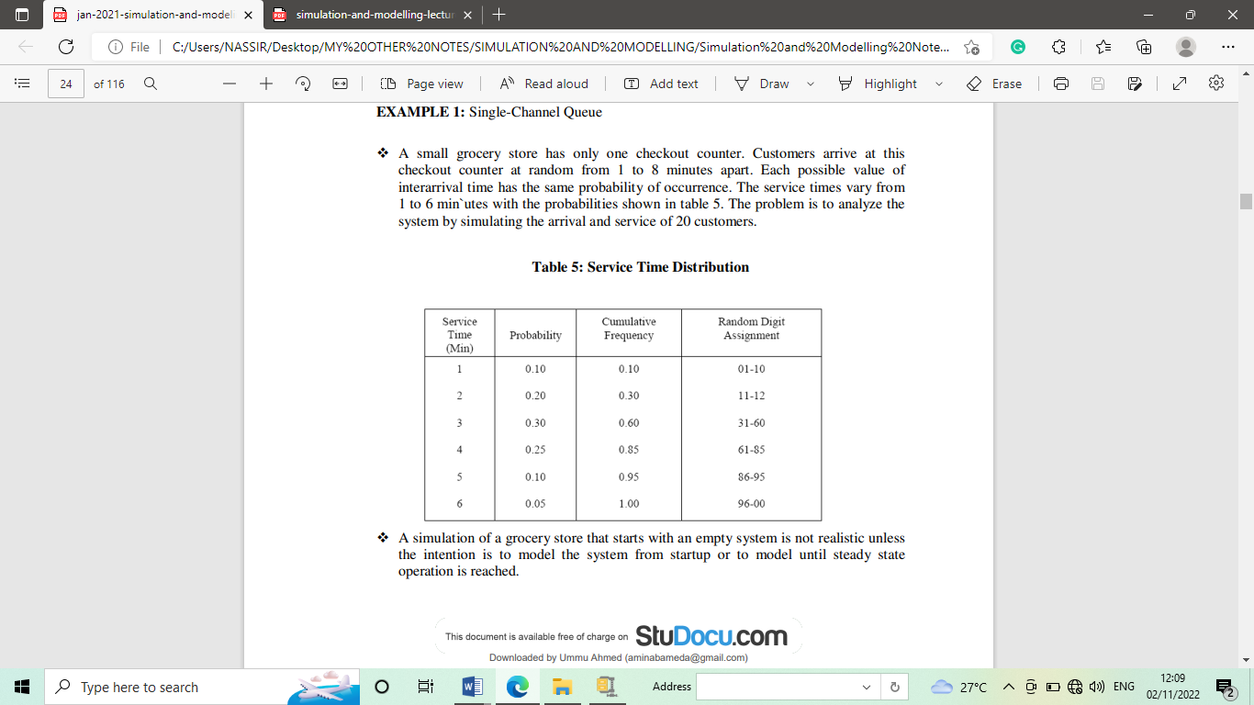

A simulation of a grocery store that starts with an empty system is not realistic unless the intention is to model the system from start-up or to model until steady state operation is reached.

A set of uniformly distributed random numbers is needed to generate the arrivals at the checkout counter. Random numbers have the following properties:

1. The set of random numbers is uniformly distributed between 0 and 1. 2.
2. Successive random numbers are independent.

The time-between-arrival determination is shown in table 6. Note that the first random digits are 913. To obtain the corresponding time between arrivals, enter the fourth column of table 4 and read 8 minutes from the first column of the table. Alternatively, we see that 0.913 is between the cumulative probabilities 0.876 and 1.000, again resulting in 8 minutes as the generated time

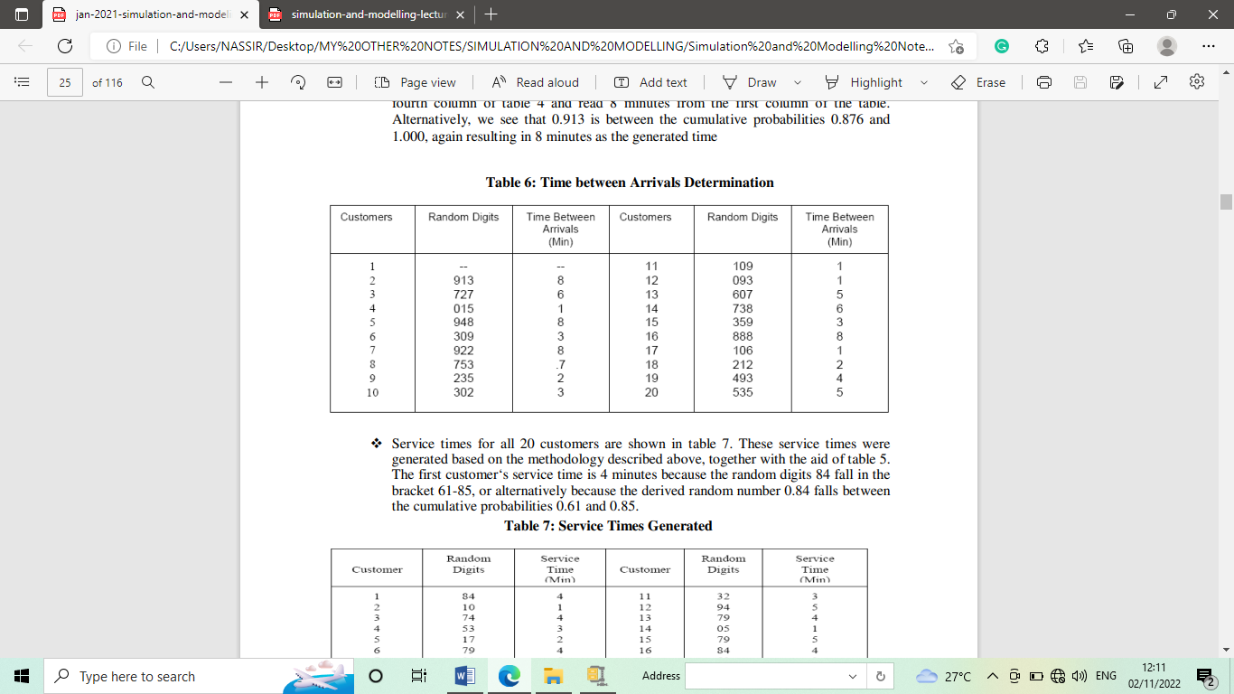

Service times for all 20 customers are shown in table 7. These service times were generated based on the methodology described above, together with the aid of table 5. The first customer‘s service time is 4 minutes because the random digits 84 fall in the bracket 61-85, or alternatively because the derived random number 0.84 falls between the cumulative probabilities 0.61 and 0.85.

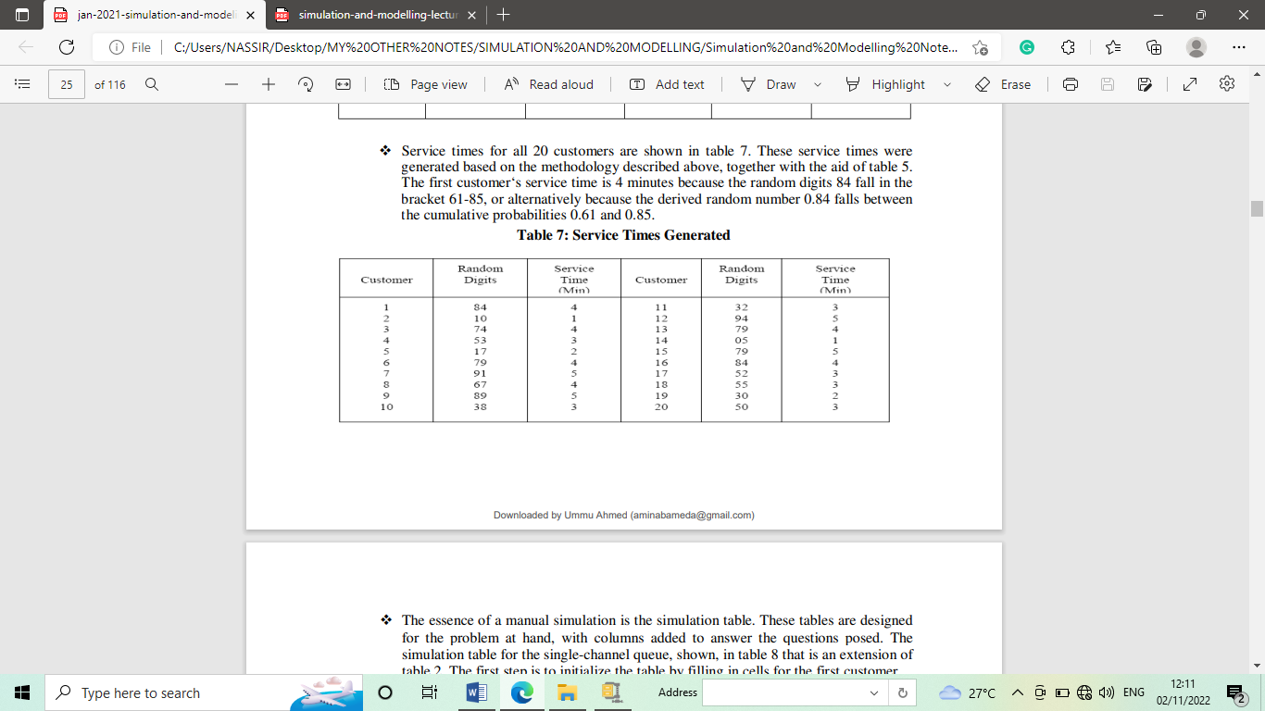

The essence of a manual simulation is the simulation table. These tables are designed for the problem at hand, with columns added to answer the questions posed. The simulation table for the single-channel queue, shown, in table 8 that is an extension of table 2. The first step is to initialize the table by filling in cells for the first customer. ϖ The first customer is assumed to arrive at time 0. Service begins immediately and finishes at time 4. The customer was in the system for 4 minutes. After the first customer, subsequent rows in the table are based on the random numbers for interarrival time and service time and the completion time of the previous customer. For example, the second customer arrives at time 8. Thus, the server was idle for 4 minutes. Skipping down to the fourth customer, it is seen that this customer arrived at time 15 but could not be served until time 18. This customer had to wait in the queue for 3 minutes. This process continues for all 20 customers.

